Profesora Miryam Bedwell
Inglés

Worksheet Unit 1 7º básico

Objetivo de Aprendizaje:
U1 OA 02.15. Escribir para informar, expresar opiniones y narrar, usando:
Concepto clave: Cantidades - Lugares

- Complete this graph with the vocabulary you remember about places in a city:
- (complete con vocabulario de la ciudad)

- Write the words for places in a town. (ordena la palabra “lugares de la ciudad)

1) acnmie: __________________ 3) bylrria: ___________________

2) phsltaoi: __________________ 4) aknb : ___________________

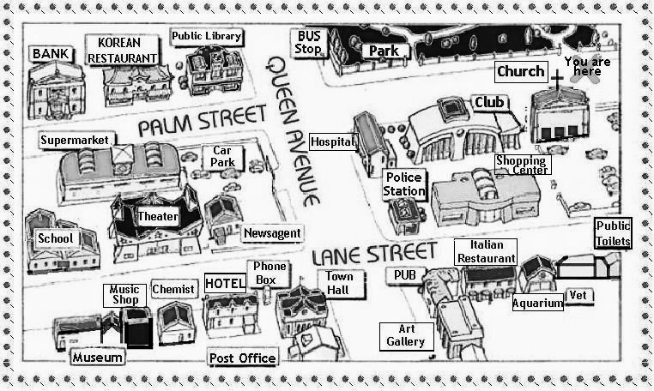

- Look at picture of a city and places in it. (mira la imagen)
- Look at the use of: there is / there are/ there isn’t / there aren´t / some / any.

EJEMPLOS: There is A supermarket. / There isn’t A swimming pool.
There are SOME restaurants. / There aren’t ANY cafés.
THERE IS (HAY 1 ELEMENTO) THERE ISN’T (NO HAY 1 ELEMENTO)
THERE ARE (HAY 2 O MÁS ELEMENTOS) THERE AREN’T (NO HAY 2 O MÁS ELEMENTOS)
A) Write: there’s, there isn’t, there are some or there aren’t any (complete)

1) ___________________ schools.

2) ___________________ a hotel.

3) ___________________ supermarkets.

4) ___________________ a cinema.

5) ____________________ a library.

6) ____________________ music shops.

7) ____________________ a hospital.

8) ____________________ restaurants.

- Complete the chart and give examples: (Completa con ejemplos)

Structure | Use | Example
There is | Single nouns  (negative: there isn’t)
There are | Plural nouns  (negative: there aren’t)

1) Look at places in the map in this city.

2) Order the words to discover a place in a city: (ordena las palabras observa el mapa)

a) kpra = ___________________ d) lhsoco = ____________________
b) olpo = ___________________ e) efca = ____________________
c) lmla = ___________________ f) nbka = ____________________

- Read the following text about Susan:

Susans’s favourite lessons is PE. That’s on Wednesday and Monday at twelve o’clock. On Thursday and Friday, she’s happy when school finishes at two thirty. She hates math because the teacher gives homework every day. She does her homework on the school bus!
There’s no school on Saturday, so in the afternoon she goes to the park with her friends, in the evening she watches television or listens to music. She likes the school holidays in summer and the holidays on Christmas and Easter. Her birthday is in December near Christmas, sometimes she likes it, but sometimes she doesn’t.

1) Extract a list of 8 VERBS from the text and check the meaning using dictionary.
(Escribe 8 verbos)

2) Read the text carefully and underline main ideas.
(subraya la idea principal)

3) Read the text carefully and complete the chart: (complete la tabla con inofrmacion del texto)

1 she hates Math, because:

2 Her favourite lesson is:

3 School holidays are on :

4 On Saturday afternoon she:

5 Her birthday is on:

6 Sometimes she likes the date of her birthday, but sometimes she doesn’t, because:

4) Write about your routine at school and at home.

On Monday I have ________________ and ___________________ at school.

My favourite subjects are _______________________________________________________

I don’t like the subject of ___________________, because_____________________________

____________________________________________________________________________

On Saturdays I like ____________________________________________________________

My birthday is on ______________________________________________________________

At Christmas, frequently my family and me __________________________________________

CAN: PODER HACER ALGO /PERMISO CAN’T : NO PODER HACER ALGO /PERMISO
MUST: DEBER /OBLIGACIÓN MUSTN’T:NO DEBER /OBLIGACIÓN
1) Listen to the dialogue carefully and complete the blanks with the words: CAN / CAN’T, MUST / MUSTN’T.

2) Practice reading aloud.

Tom: ______________ I go to James’s house?
Mum: Yes, you _____________, but you ______________ me
in the kitchen first.
Tom: _____________ I stay until twelve o’clock?
TOM Mum: No, you ________________ you ____________come home
early.
Tom: Mum, _______________ I have some money for school, on
Monday?
Mum: Yes, you _______________, but you ___________buy sweets.

Tom: Ok mum. And _________________ I go out now.

Mum: No, you ________________. You ______________ finish your
homework first and then you ______________ go out.

