Profesora Miryam Bedwell
Inglés

Worksheet Unit 1 8º básico

Objetivo de Aprendizaje
UN 1 OA 3-5-6- 7-8-10- 13-15. Escribir información relevante

ADVERBS (adeverbios)
NEVER, ALWAYS SOMETIMES mean? _________ __________ ____________

- Look at the line and percentages and write the corresponding word under the percentage. (escribe según el porcentaje de frecuencia NEVER, ALWAYS, SOMETIME)

[______________________[_________________________[
0% 50% 100%
______________ ________________ _______________

- Underline or cross out the extra adverb in each sentence. (subraya el adverbio de tiempo)

Example: Martina always gets up always at seven o’clock. Martina
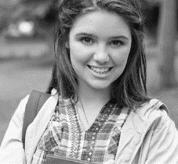
1) Never Martina never drinks tea for breakfast.

2) She sometimes washes sometimes the dishes.

3) Martina’s sister always watches TV after always school.

4) She never make her never bed in the morning.

5) Her father sometimes helps sometimes her with her homework.

6) She always plays basketball always on Saturdays mornings.

“Are computers games bad for you?”

Playing computers game is one of the most popular free-time activities for young people, but experts say that playing for hours and hours can damage your health.
Some young people who play computer games a lot don´t get enough exercise, and they should walk at least. They often eat junk food while they play. They put on weight and sometimes become obese.
The physiotherapists say that people shouldn’t play for hours and hours without a rest, you should relax your fingers and hands every thirty minutes. To protect your column, you should keep your back straight and sit in the correct distance from the screen. The people who sit too near the screen often get headaches and can damage their eyes.
Psychologists say that, young people shouldn’t spend all their free time in front of a computer or TV screen. They should keep active and do lot of different activities, including playing computer games.

- Read the text again and write four main ideas from the text: (lee y escribe las ideas centrales del texto)

1. ___________________________________________.
2. ___________________________________________.
3. ___________________________________________.
4. ___________________________________________.

2) Answer: True or false (correct the false ones).

1) ______ Young people shouldn’t spend more than an hour playing computer games.

2) ______ People who sit near a screen cannot damage their eyes.

3) ______ Sometimes teenagers eat a lot of junk food, while they play.

4) ______ Obesity is not a problem for young people who play for hours computer games.

5) ______ Sitting incorrectly in front of the computer or TV screen can give you a
backache or headache.

6) ______ Teenagers should keep active doing a lot of activities.

- Write six pieces of advice related to entertaining activities for young people, including computer games.

Eg. You SHOULD play sports on weekends.

1) _____________________________________________________________

2) _____________________________________________________________

3) _____________________________________________________________

4) _____________________________________________________________

5) _____________________________________________________________

6) _____________________________________________________________

- Read and listen to the text about the actor Ewan McGregor. Underline the verbs past form. (lee y subraya los verbos en pasado)
Ewan McGregor was born in Scotland in 1971, He __________ (decide) to be an actor when he was only nine and he __________ (make) his first film in 1992. In 2010 he __________ (appear) in a lot of different types of film, including comedies, musicals, dramas and the Star Wars movies. His uncle, Danis Lawson, ___________ (be) an actor in the original Star Wars in 1977 and McGregor __________ (work) in his first Star Wars movie 22 years later. Ewan ______________ (do) a job team with actresses like Cameron Diaz and Nicole Kidman, and his films ____________ (win) lots of awards years ago. He loves acting.

- Complete features about famous people. If you don’t know the information, you can use a computer or your mobile phone to find it:
(complete la información de los siguientes artistas busca en internet)

1) Name: ________________________________ 1) Name: __________________________
2) Nationality: _____________________ 2) Nationality: _________________
3) Profession: ______________________ 3) Profession: _________________
4) Famous film or song: ______________ 4) Famous film: ________________
_________________________________ ____________________________
- Write the fact file of your favourite artist: (complete la informació acerca de tu artista favorite)
Name: _____________________________________________________
Date of birth: ________________________________________________
Place of birth: _______________________________________________
Job: _______________________________________________________
International hits: _____________________________________________
Hobbies: ___________________________________________________

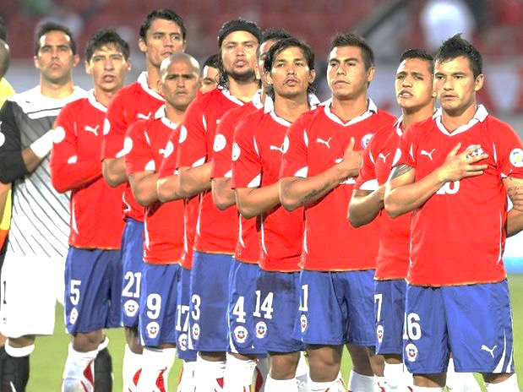

- Read the article in silence and underline the main ideas. (lee y subraya las ideas centrales)
The Chilean National Football Team represents Chile in international football and it is controlled by the Chilean Football Federation (FFC), the governing body for football in Chile.
The FFC was founded in 1895, it became a member of FIFA in 1913, and a member of CONMEBOL in 1916. Chile is one of the four founding member nations CONMEBOL. Together with Argentina, Brazil, and Uruguay, the four competed in the first South American Championship in 1916, later to be renamed the Copa America. The country's history of football began with English sailors and their boat trips due to various commercial links between Chile and Great Britain in the 19th century. The first professional league was founded in 1933.
The Chilean national team plays their qualifying matches at the Estadio Nacional de Chile located in Santiago, Chile and can be found at the district of Ñuñoa. The construction of the stadium began in February 1937, and opened on 3 December 1938. The current official registered capacity is of 49,000 spectators, but has surpassed the 75,000 mark on many occasions when the match is of high demand. An example would be the 1962 FIFA World Cup Semi-final match Chile vs. Brazil, where over 76,000 spectators viewed the game. The maximum attendance ever was 85,262 on December 26, 1962 for a game between Universidad Católica and Universidad de Chile.

- Extract six verbs in past from the text. (escribe verbos en pasado del texto)

________________________ _________________________
________________________ _________________________
________________________ _________________________

- Complete the chart with the correct information: (complete con información del texto)

Meaning of FFC:
Country which has the footballs’ origins:
First name of Copa America:
It controls the Chilean National Football team:
Maximum capacity of people for the National Stadium:
The FFC become a member of FIFA in:

- Correct the VERBS in past tense and rewrite the sentence.
- (escribe las oraciones transformando el verbo (está en negrita) en pasado)
Chile plaid against Uruguay last year.
Chile played against Uruguay last year .

Chile never wan the CONMEGOL.

The construction of the stadium bigin in 1937.

The top capacity of the stadium were in 1962.
____________________________________

